Ideation Phase
Empathize & Discover

Date | 25 September 2026
Team ID | SWTID-2026-4296
Project Name | AI StudyBuddy
Maximum Marks | 4 Marks

User Description
An empathy map is a simple, easy-to-digest visual that captures knowledge about a user.
A student who regularly studies from different learning materials and wants to reduce the time and effort required for understanding, revising, testing, and organizing study content.

1. THINK & FEEL
What does the user think and feel?
- "I want to understand my study materials quickly."
- "Reading lengthy study materials takes too much time."
- "I need an easier way to revise important concepts."
- "I want to create useful study resources from my materials."
- "I want to summarize lengthy content quickly."
- "I want to create flashcards without preparing them manually."
- "I want to test my knowledge before examinations."
- "I need a personalized study plan based on my exam schedule and available time."
- "I want my learning resources to be organized and easily accessible."

2. HEAR
What does the user hear from others?
- Other students talk about using AI tools for learning and revision.
- People recommend AI-assisted study and learning tools.
- Teachers and classmates emphasize the importance of regular revision.
- Students discuss the difficulty of managing large amounts of study material.
- Others recommend using quizzes and flashcards for better revision.
- Students hear about the importance of planning their preparation before examinations.
- Users hear that secure authentication is important for online learning platforms.

3. SEE
What does the user see around them?
- Large amounts of study materials such as PDFs, notes, textbooks, and articles.
- AI tools being increasingly used for learning assistance.
- Long study materials that require considerable reading time.
- Different applications for notes, revision, quizzes, and study planning.
- Manual preparation of notes and revision questions.
- Students spending significant time preparing study resources.
- Increasing need for personalized and efficient learning methods.

4. SAY & DO
What does the user say and do?
- Searches for study materials before examinations.
- Reads and reviews notes, PDFs, textbooks, and other learning content.
- Prepares notes and revision materials manually.
- Creates questions and flashcards for revision.
- Looks for ways to save time while studying.
- Uses online tools to understand difficult concepts.
- Wants to summarize lengthy study materials.
- Wants to test knowledge through quizzes.
- Plans study activities according to examination schedules.
- Wants to save and access previously generated learning resources.

5. PAIN
What problems/frustrations does the user experience?
- Understanding lengthy study materials takes considerable time.
- Manual preparation of notes consumes valuable study time.
- Creating flashcards and revision questions is repetitive and labor-intensive.
- Creating quizzes manually requires additional effort.
- Lack of personalized study plans makes preparation difficult to organize.
- Study materials are scattered across multiple sources.
- Switching between different applications for notes, quizzes, and scheduling is inconvenient.
- Managing and accessing previously created learning resources can be difficult.
- Limited preparation time can make examination revision stressful.

6. GAIN
What does the user want to achieve?
- Faster understanding of study materials.
- AI-assisted study support.
- Quick and concise content summarization.
- Automatic flashcard generation.
- AI-generated quizzes for self-assessment.
- Personalized study plans.
- Centralized learning resource management.
- Secure user authentication.
- Reduced manual study effort.
- Better productivity and more effective revision.
- More time to focus on understanding concepts and preparing for examinations.
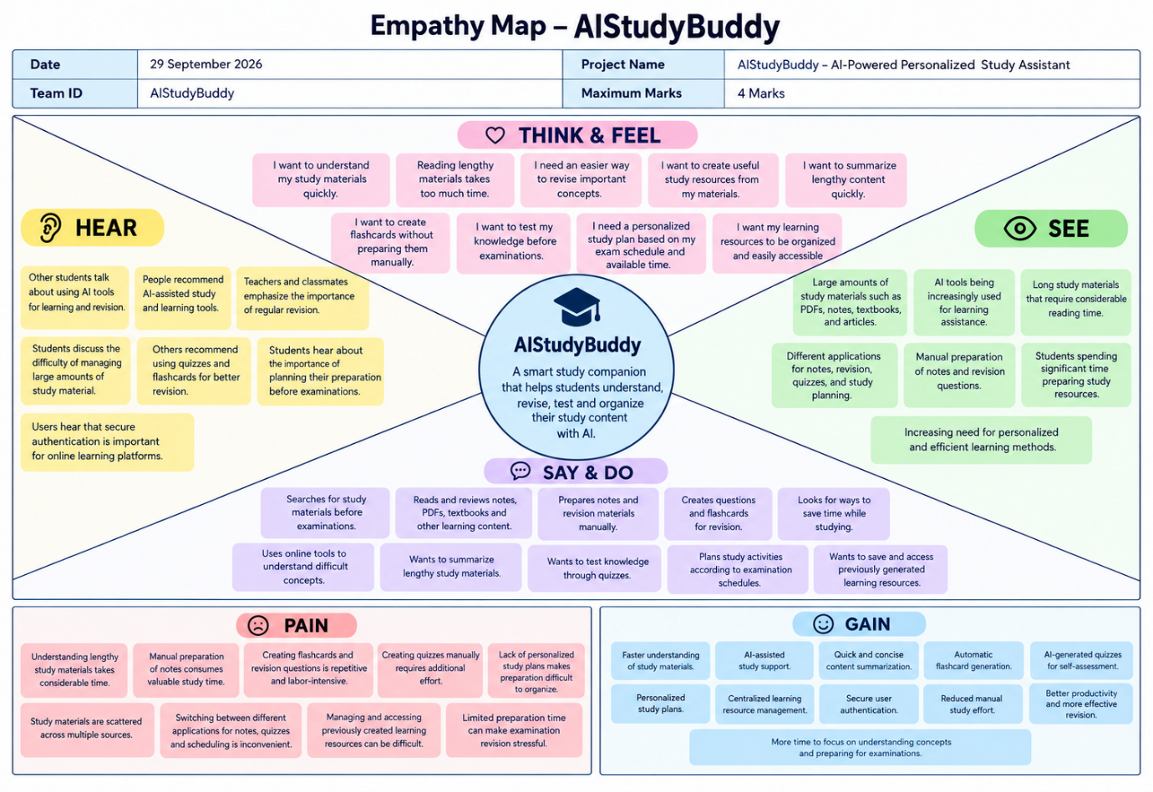
Reference: https://www.mural.co/templates/empathy-map-canvas

